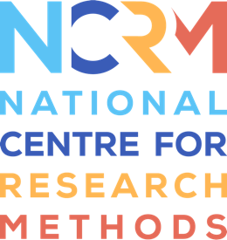
Draw Your Breath

Transcript
Full resource: https://www.ncrm.ac.uk/resources/online/all/?id=20812

Gil Dekel: Hello, colleagues. In this video, I will explain the ‘Draw Your Breath’ method. In the other video, I'm sharing the method's guided meditation.
Draw your Breath, to help promote observational skills for art and technologies.
Students often find it hard to focus their thoughts and to come up with creative ideas for research. They find it hard to think through what they want to achieve. With so many distractions out there, how can students, and anyone really, you and me, connect to an inner meaningful space which is informative and safe?
I'm proposing the Draw Your Breath method, which is basically a reflective method. It is using simple guided meditation, simple arts and technologies to build deep relations with the inner self. What happens when you build up relations with yourself? Well, you enter a stage where you can focus your thinking; you learn to observe and listen to your intuitive knowledge.
We do that by engaging with participants while they are still in the relaxed stage, not before and not after. While they're still in the relaxed stage, when the body and mind are relaxed, I ask them to open their eyes and start to draw their breathing pattern on a piece of paper.
Now, we know that art moves people away from their comfort zone, and we know that breathing is very much an individual activity. Art and breathing together create a sense of ownership. Participants own their work and their experience. It is all about ‘know thy self’… constructivist pedagogy, where we're creating knowledge while reflecting, here demonstrated with the famous ‘Hamsa Hand’ with the all-knowing eye.
Once the students complete their work, we ask them to upload it into this digital board, and the unique thing is that any work here is authentic and it is correct, it represents the person. There is no wrong, and all the works are sitting right next to each other. There is a space given, a voice, to everyone. Participants need to have paper in front of them and a pen or a marker.
In the other video, I'm sharing the guided meditation. Good luck.

National Centre for Research Methods (NCRM)
Social Sciences
Murray Building (Bldg 58)
University of Southampton
Southampton SO17 1BJ
United Kingdom
Web www.ncrm.ac.uk
Email info@ncrm.ac.uk
Tel +44 23 8059 4539
Twitter @NCRMUK

